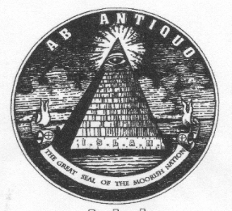
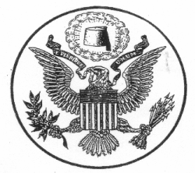

THE MOORISH DIVINE AND NATIONAL MOVEMENT OF THE WORLD
Aboriginal and Indigenous Natural Peoples of North America

Notice Of Public Records Correction

This correspondence and Public Notice is hereby presented and forwarded to your company or corporate officials, personnel, and employees, relative to my corrected and changed attribute / name, along with proper spelling. You are hereby given honorable notice to correct any records, files, mailings, and other future correspondences, accordingly.

This correction is made in accord with the honoring of my family bloodline / pedigree, and exercising my natural substantive rights and religious heritage. Please correct your records as soon as possible.

The former name, Jane Doe, is to be corrected on all records replaced with the name, your proper name.

Thank You,
____________________________________
Your Name
Natural Person, In Propria Persona: All Rights Reserved

