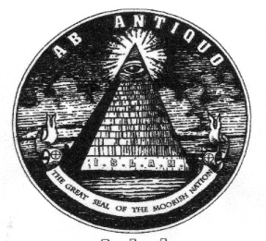
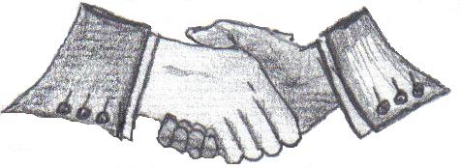

THE MOORISH NATIONAL REPUBLIC FEDERAL GOVERNMENT NORTHWEST AFRICA.
THE MOORISH DIVINE AND NATIONAL MOVEMENT OF THE WORLD.
Northwest Amexem / Northwest Africa / North America.
‘The North Gate’.
Societas Republicae Ea Al Maurikanos.
Aboriginal and Indigenous Natural Peoples of the Land.
The true and de jure Al Moroccans / Americans

Averment Of Jurisdiction - Quo Warranto

For The Record, To Be Read Into The Record
Notice to Agent is Notice to Principal – Notice to Principal is Notice to Agent.

September 10, 2010
<CORPORATION NAME>
<NAME OF PERSON>
<ADDRESS>
<CITY, STATE ZIPCODE>

Re: <BILL OF ATTAINER No.>

Res Judicata
Hagans v Lavine 415 U.S. 533., There is no discretion to ignore lack of jurisdiction. Joyce v U.S. 474 2d 215; The law provides that once State and Federal jurisdiction have been challenged, it must be proven. Main v Thiboutot 100. S. Ct 2501 (1980); " Jurisdiction can be challenged at any time " and "jurisdiction, once challenged, cannot be assumed and must be decided". Basso v Utah Power and Light Co. 495 F.2d 906,910.

As all government entities and alleged private corporations must be a creature of the American Constitution, this is a formal Request and Command for <NAME OF CORPORATION> and/or <NAME OF AGENTS/OFFICER> to produce for the record, the physical documented ‘Delegation of Authority’, as Proof of Jurisdiction, as required by Law, per Article III, Section 1 of the United States Republic Constitution.

PUBLIC HAZARD BONDING OF CORPORATE AGENTS All officials are required by federal, state, and municipal law to provide the name, address and telephone number of their public hazard and malpractice bonding company and the policy number of the bond and, if required, a copy of the policy describing the bonding coverage of their specific job performance. Failure to provide this information constitutes corporate and limited liability insurance fraud (15 USC) and is prim a facie evidence and grounds to impose a lien upon the official personally to secure their public oath and service of office. (18 USC 912).

"Whoever, having taken an oath before a competent tribunal, officer, or person, in any case in which a law of the United States authorizes an oath to be administered, willfully and contrary to such oath states or subscribes any material matter which he does not believe to be true, is guilty of perjury and shall be fined no more than $2,000.00 or imprisoned not more than five years or both." 18 U.S.C. §1621

Thank You,
I Am: ______________________________
<FreeNationalName, Ex-Relatione <StrawName>
Authorized Representative
Flesh and Blood Being, In Propria Persona
All Rights Reserved: U.C.C. 1-207/1-308; U.C.C.1-103
[c/o Street Near CITY STATE]
Northwest Amexem

cc:
United Nations Honorable President Barack Obama
High Commissioner for Human Rights White House Washington DC
Palais Wilson
United States Department of State
International Criminal Court Hillary Clinton
Luis Moreno-Ocampo
Great Seal National Association of Moorish Affairs
International Court of Justice Minister :A-El / Minister Taj Tarik Bey / Minister William Salaam Hall:El
Peace Palace
The Hague Netherland United States Justice Department
Attorney General Eric H. Holder Jr.
Interpol
Lyon, France

